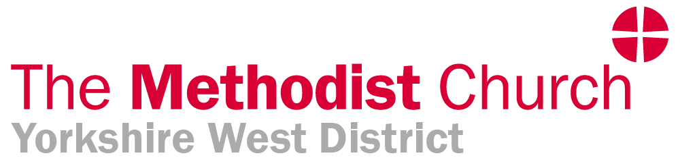

Application for a Grant from the District CDiM Fund

Name: | Circuit:
Address: | Email:
Purpose/s of application:
In what way/s will this enhance your ministry:
How much time will this development take & when is it to take place:
What is the total cost of the development: £
What amount of grant are you applying for: £
Have you previously applied for CDiM grants in this Connexional year: Yes / No
If Yes, what is the total of CDiM grants applied for this year: £
If you would like payment by direct bank transfer please provide:
Sort Code: Account Number:
Account Name: (Otherwise payment will be made by cheque.)

Signed: ………………………………………………………………………… Date: …………………..

Completed forms are to be sent to admin@ywmethodist.org.uk if an electronic signature is appended. Otherwise, please print and sign a paper copy and post to the District Office, Touchstone, 4 Easby Road, Bradford, BD7 1QX.

Please ensure that the superintendent/Chair of District has been copied into this application.

Amount of grant approved: £

Approved on behalf of the District:

Signed: ………………………………………………………………………… Date: …………………..
Notes

Claims must be made within the Connexional year in which the training/retreat/ development takes place and the deadline for submitting claims annually is 31 July.

In the Connexional year 2021/22 a maximum of £250 may be claimed.

Please remember that claims cannot be made for academic study or books. If you are unclear about what you can claim for please contact the District Office.

Probationer ministers do not come within the CDiM Scheme as probationer studies are the responsibility of Formation in Ministry Office.

This scheme does not cover Authorised Ministers and Deacons or Associate Ministers and Deacons.

In some circumstances Recognised and Regarded Ministers are covered by the CDiM Scheme and advice should be sought from the Chair of District as necessary.

Revised August 2021

